Batch: A4 Roll No.: 1914078 Experiment: 9 Lab Work

Categorizing data based on Order Date, Sub-Category and Sales:

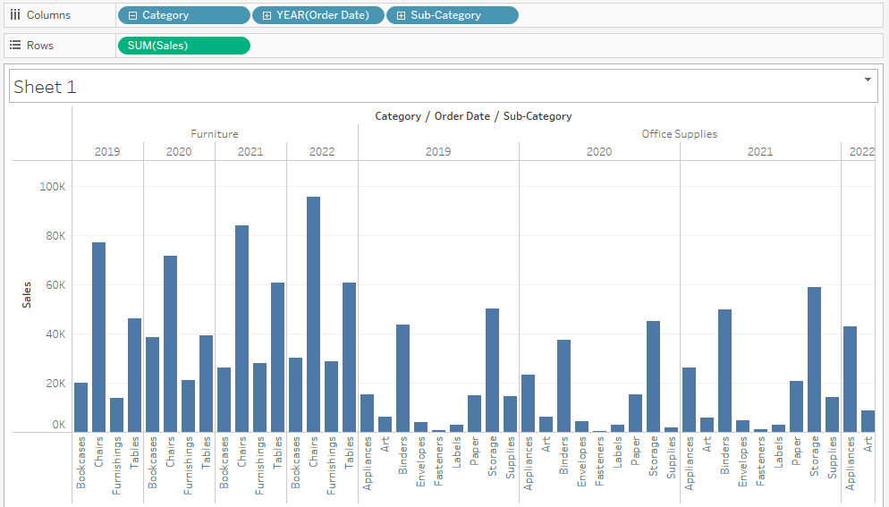

Filtering data based on Order Date (Year) and Sub-Category



Distributing data based on Order Date (Year) and Profit gained:

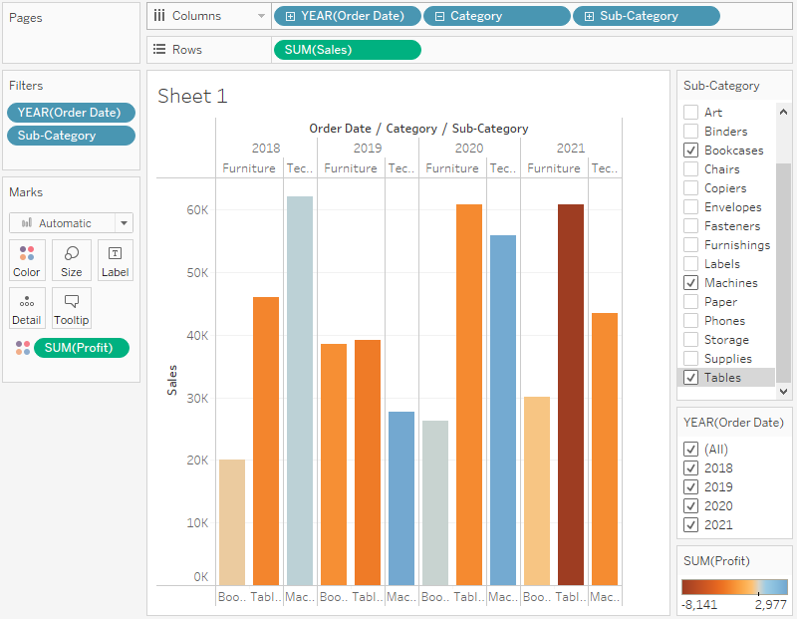

Plotting data based on Longitude, Latitude & States:

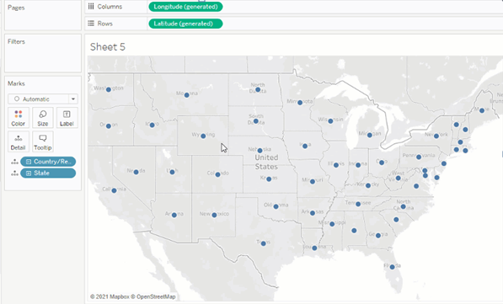

Showing Profit gained by each State and Country:

